**RISC Processor**

[**GITHUB**](https://github.com/ziadnasser19/RISC-Processor)

**Computer Architecture**

**Supervised by: Dr. Gihan Naguib**

**Presented for: Eng. Jihad Awad**

**By:**

[**Amr Alaa**](https://www.linkedin.com/in/amr-alaa-eldin-a07743185/)

[**Zyad Mohammad**](https://www.linkedin.com/in/ziad-mohamed-ce/)

[**Ziad Nasser**](https://www.linkedin.com/in/ziad-nasser-96a016279/)

**Table of Contents:**

1. Introduction ………………………………………………..……
2. Phase One Components ……………………………………..
   1. PC Control ……………………………………………….
      1. Branch Control ………………………………….
   2. Instruction Memory ……………………………………..
   3. Register File……………………………………………….
   4. ALU …………………………………………….................
   5. Extender ………………………………………………….
   6. Data Memory ……………………………………………
   7. Control Unit ………………………………………………
3. Testing ……………………………………………………………..
   1. Sum of an Array …………………………………………
   2. Test Code 2024_v2 ……………………………………..
   3. Test 0 ………………………………………………………
   4. Test 1 ……………………………………………………….
   5. Multiplication and Applications Test ………………...
      1. Multiplication Function …………………………
      2. Powers ……………………………………………..
      3. Product of an Array……………………………...
4. Teamwork ……………………………………………………………………………………….

**1. Introduction**

For this project, the objective is to create a basic 16-bit RISC processor featuring seven general-purpose registers labeled R1 to R7. R0 is set to zero and cannot be modified, so we have seven usable registers. Additionally, there is a single 16-bit special-purpose register, the program counter (PC). The PC register enables access to a total of instructions. All instructions are limited to 16 bits in length. The processor supports three instruction formats: R-type, I-type, and J-type, each with its own structure and purpose.

**R-type format:**

The R-type format consists of a 5-bit opcode (Op), a 3-bit destination register (Rd), two 3-bit source registers (Rs and Rt), and a 2-bit function field (F).

|  |  |  |  |  |
| --- | --- | --- | --- | --- |
|  |  |  |  |  |

**I-type format**

The I-type format includes a 5-bit opcode (Op), a 3-bit destination register (Rd), a 3-bit source register (Rs), and a 5-bit immediate value.

|  |  |  |  |
| --- | --- | --- | --- |
|  |  |  |  |

**J-type format**

The J-type format is comprised of a 5-bit opcode (Op) and an 11-bit immediate value.

|  |  |
| --- | --- |
|  |  |

After analyzing the required instructions, we identified the necessary components for the processor's data path. We then designed each of these components and successfully implemented all the targeted instructions.

**The main components:**

1. PC Control
2. Instruction Memory
3. Register File
4. ALU
5. Extender
6. Data Memory
7. Control Unit

**2.1. PC Control**

The Program Counter Control is the component which is responsible for generating the next PC value.

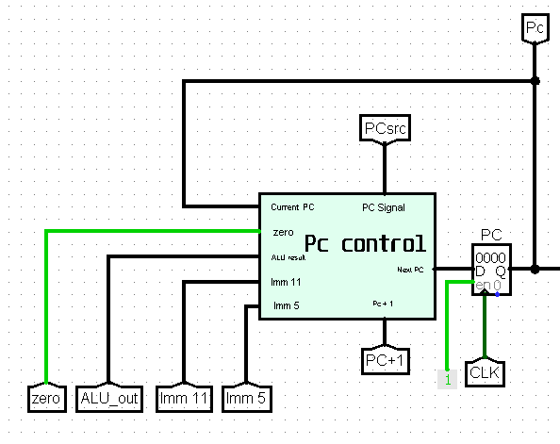

The PC Control Signal is called PC Src and it is used to decide how the next PC value will be calculated.

**2.1.1. The Next PC Values**

1. ***PC + 1:***

* This is the main value of the next PC.
* Used for most of the instruction.
* Calculated by adding 1 to the current PC address.
* Its PC Src signal is (xx00).

1. ***Reg (Rs):***

* Used for the Jump Register (JR) instruction.
* In JR instruction Rs is added to 0 and the Pc control takes the result as ALU result and stores that value as the new PC.

1. ***PC + sign-extend (Imm11):***

* Used for the Jump/Jump and Link (J/JAL) instructions.
* The new pc value is the sign extended value of Imm(11) added to the current PC address.

1. ***PC + sign-extend (Imm5):***

* Used for the branch (BEQ/BNE/BLT/BGE) instructions.
* The new pc value is the sign extended value of Imm(5) added to the current PC address.

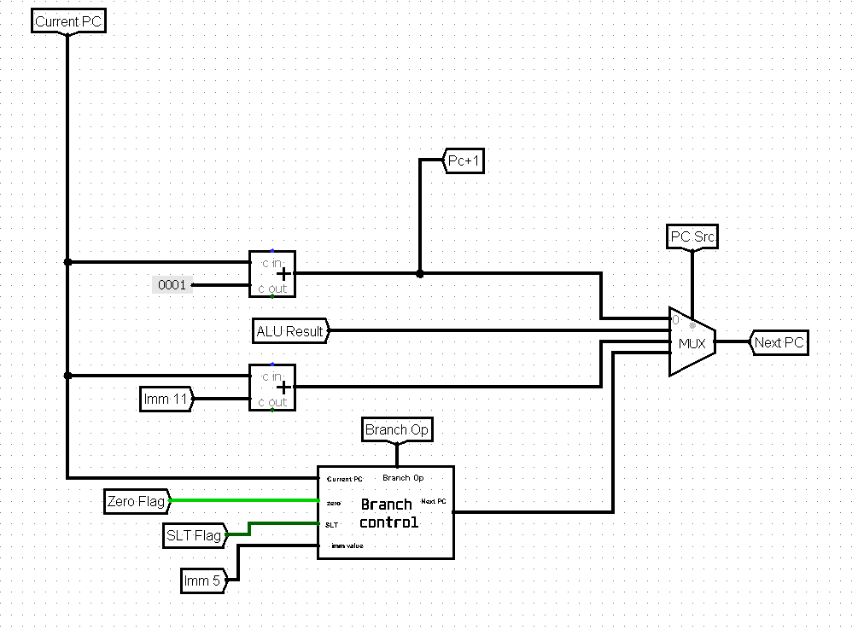

**2.1.2. Branch Control**

In the case of a branch instruction the next PC value is either PC + 1 or PC + sign-extend (Imm5). The Branch Control unit uses the zero flag to check for equality and inequality and the SLT flag to check for less than and greater or equal conditions.

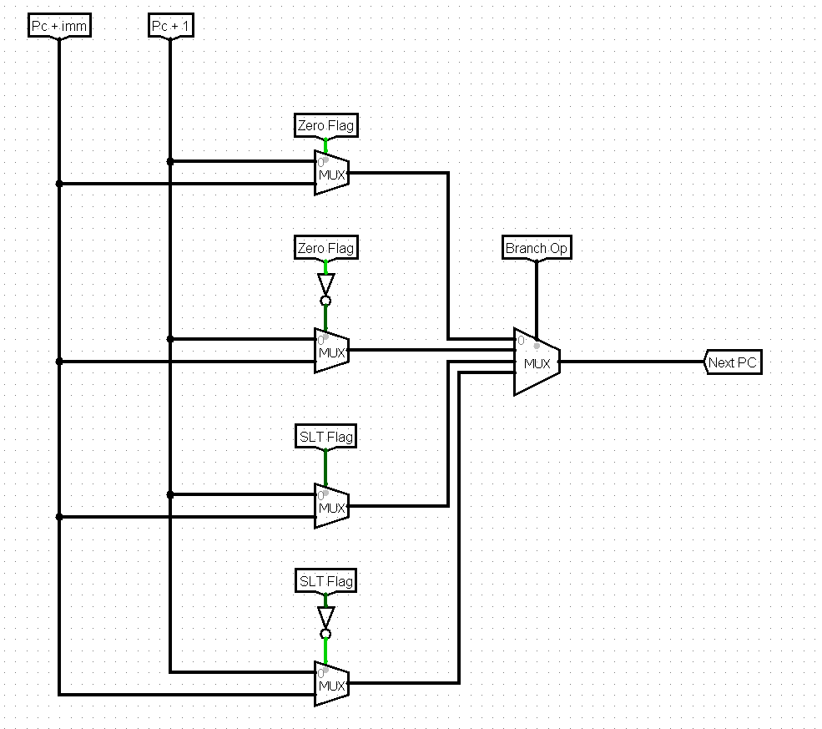

**2.2. Instruction Memory**

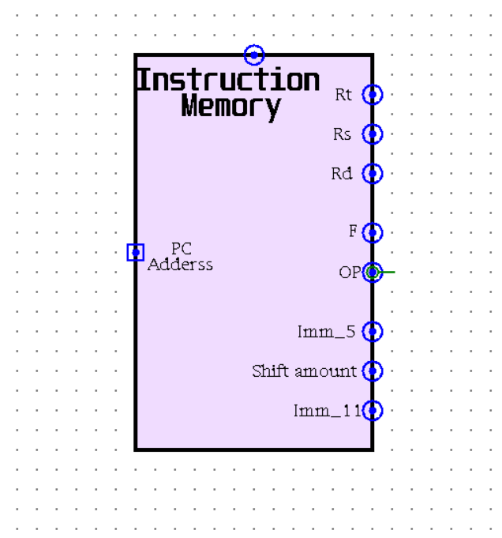The instruction memory serves as a fundamental component, serving as the starting point for all operations. Operating as a read-only memory (ROM), it is pivotal in program execution. With only one input, it relies on the Program Counter (PC) address to determine the output instruction.

From the 16-bit instruction, we derive eight crucial outputs: bits 0-2 designate Rt, bits 3-5 correspond to Rs, bits 6-8 represent Rd, bits 9-10 signify Function, bits 11-15 denote Opcode, bits 6-10 encode a 5-bit immediate value, bits 0-10 encapsulate an 11-bit immediate value, and bits 6-9 indicate the shift amount.

These eight outputs assume a critical role in program execution, as subsequent operations hinge upon their values, guiding the flow of the program.

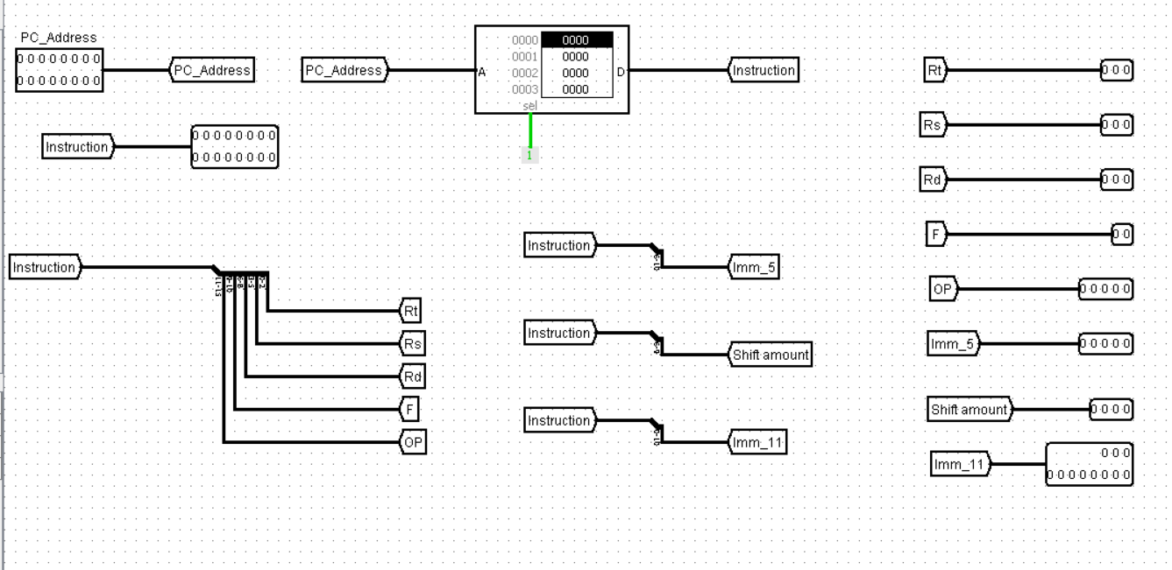

***Internal Architecture***

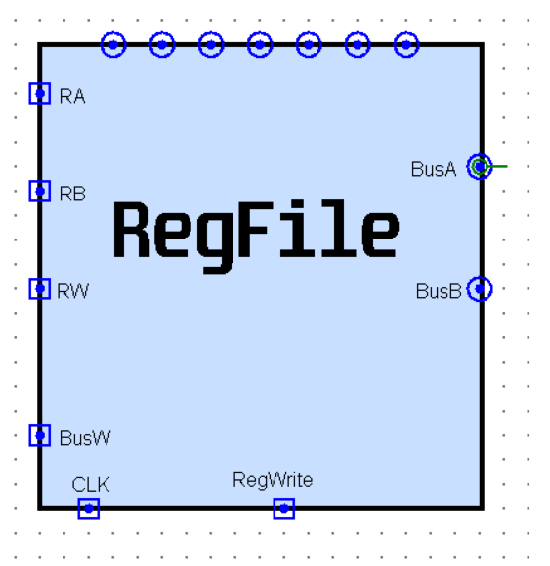**2.3. Register File**

For Register file we have 2 sub circuit:

1. Sub Register
2. Register Selector

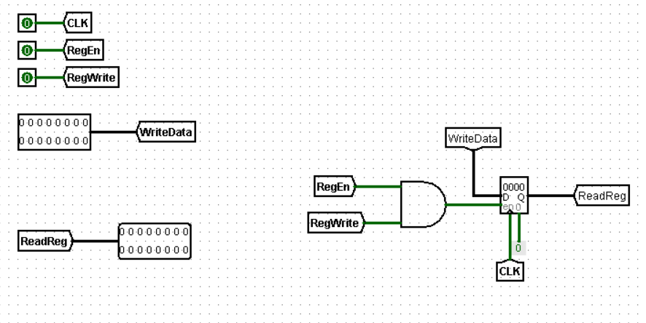**2.3.1. Sub Register**

A sub register is a component that represents an individual register within the processor's data path. It has two data ports: one for input and one for output. It also has an enable signal that controls when the register can participate in data transfers.

**To enable a sub register for writing data, two conditions must be met:**

1. The general RegWrite signal must be active (typically logic 1). This signal indicates that a write operation is happening to one of the registers in the data path.
2. The sub register's specific enable signal (often called reg_enable) must also be active (logic 1). This signal selects which specific register within the register file will be written to.

In essence, the RegWrite signal acts as a global write enable for the entire register file, while the Reg_enable signal acts as a specific selector for a particular sub register. Both signals need to be active for a successful write operation to a specific register.

**2.2.3. Register selector**

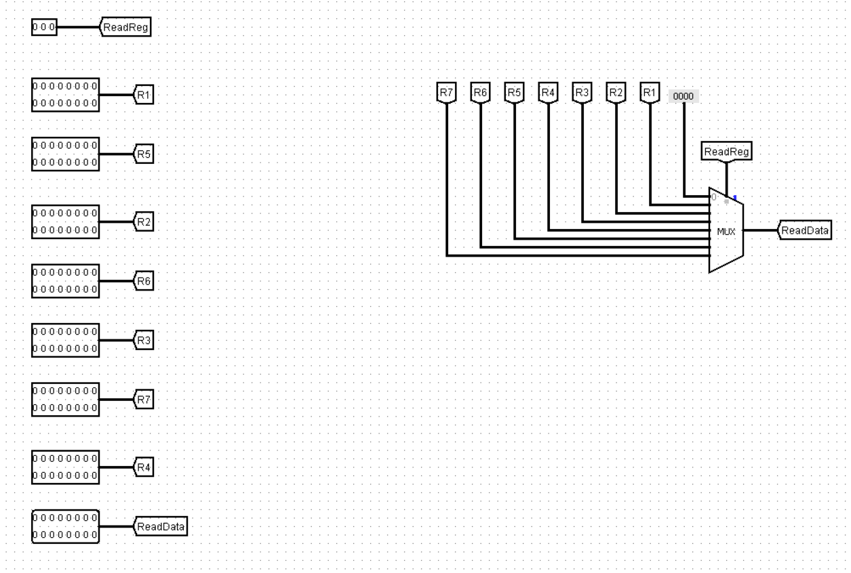To choose the correct register for reading data during instruction execution, we employ a specialized circuit called the register selector.

The register selector receives a control signal derived from the decoded instruction. This signal typically consists of 3 bits, representing the register number within the register file. For 3 control bits, this allows selection from = 8 register.

**A common implementation for the register selector is a 3*8 multiplexer (MUX). Here's how it works:**

* 3 select lines: These receive the control signal bits from the decoded instruction, specifying the desired register to read from.
* 8 data input lines: Each line connects to the output of a different sub register in the register file.
* 1 data output line: This line provides the data from the selected register, which becomes the source data for the instruction.

During instruction execution, when the processor needs to read data from a register, the decoded Instruction provides the control signal to the MUX. The MUX then routes the data from the selected register's output line to the data output line of the register selector. This data becomes the source for further processing within the instruction.

**2.2.4. Building the sub circuits**

Our foundation lies in the subregister, a fundamental building block discussed earlier. Each subregister represents an individual register in the data path, responsible for data input, output, and enabling signals.

To create a complete register file with eight registers, we'll replicate this subregister seven times. This provides us with the core components for registers r1 through r7.

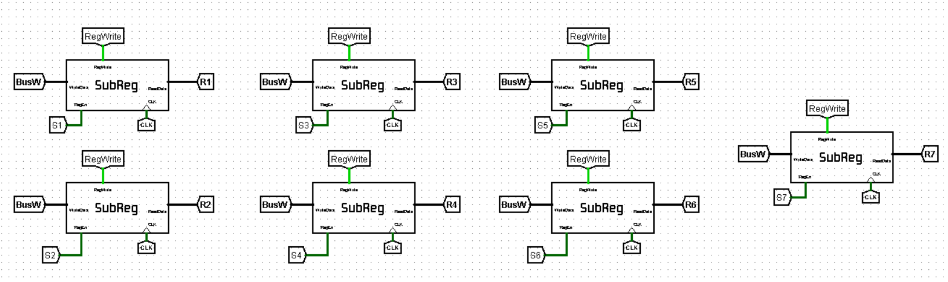(register r0 is typically hardwired with zero to ensure consistent behavior and simplify operations within the process)

**2.2.5. Reading from the Register File**

The register file provides the ability to read data from two registers simultaneously. To achieve this, we employ two register selectors. Each selector receives a control signal (typically 3 bits) from the decoded instruction, allowing it to choose a specific register for reading.

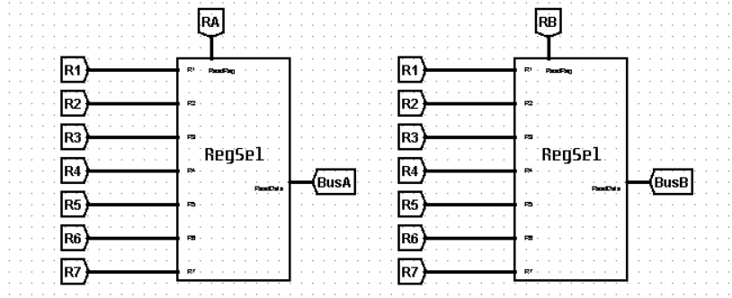

**2.2.6. Writing to the Register File**

While the register file can receive data through a single input (data.in), only one register can be written to at a time. To ensure this controlled write operation, we utilize two signals:

* RegWrite Signal: This global signal acts as a master switch. When active (typically logic 1), it indicates that a write operation is happening to one of the registers.
* Register Enable Signal: Each register within the file has its own enable signal (often a 3-bit field decoded from the instruction). Only when both the RegWrite signal is active and the correct register's enable signal is activated, will data be written to that specific register.

The register enable signal utilizes a decoder circuit. This decoder receives the 3-bit control signal from the instruction and activates only one of its output lines based on the binary value. This ensures that only the selected register's enable signal goes high, allowing data to be written to that specific register within the register file.

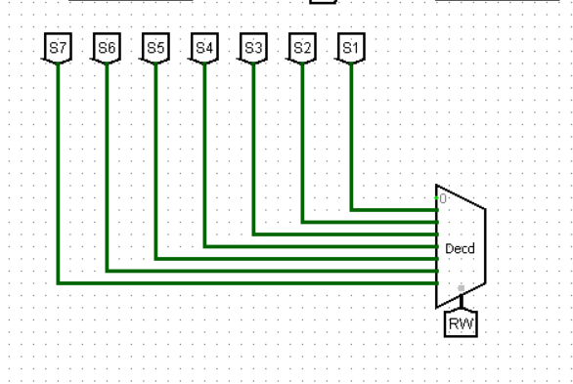

**2.4. ALU**

Every computer needs a part that can do math and follow instructions. Inside the processor, this critical job belongs to the **ALU**, or Arithmetic Logic Unit. Think of it as a tiny, built-in calculator that can add, subtract, compare things, and even move bits around.

But the ALU isn't just one simple unit. To handle all these tasks efficiently, it's actually made up of three smaller specialists working together:

* **The Arithmetic Unit:** This part focuses on math operations, like adding and subtracting numbers.
* **The Logic Unit:** This specialist handles comparisons and logical operations like AND or OR helping the processor make decisions.
* **The Shift Unit:** This unit is a bit shifter, moving data bits left or right as needed for various computing tasks.

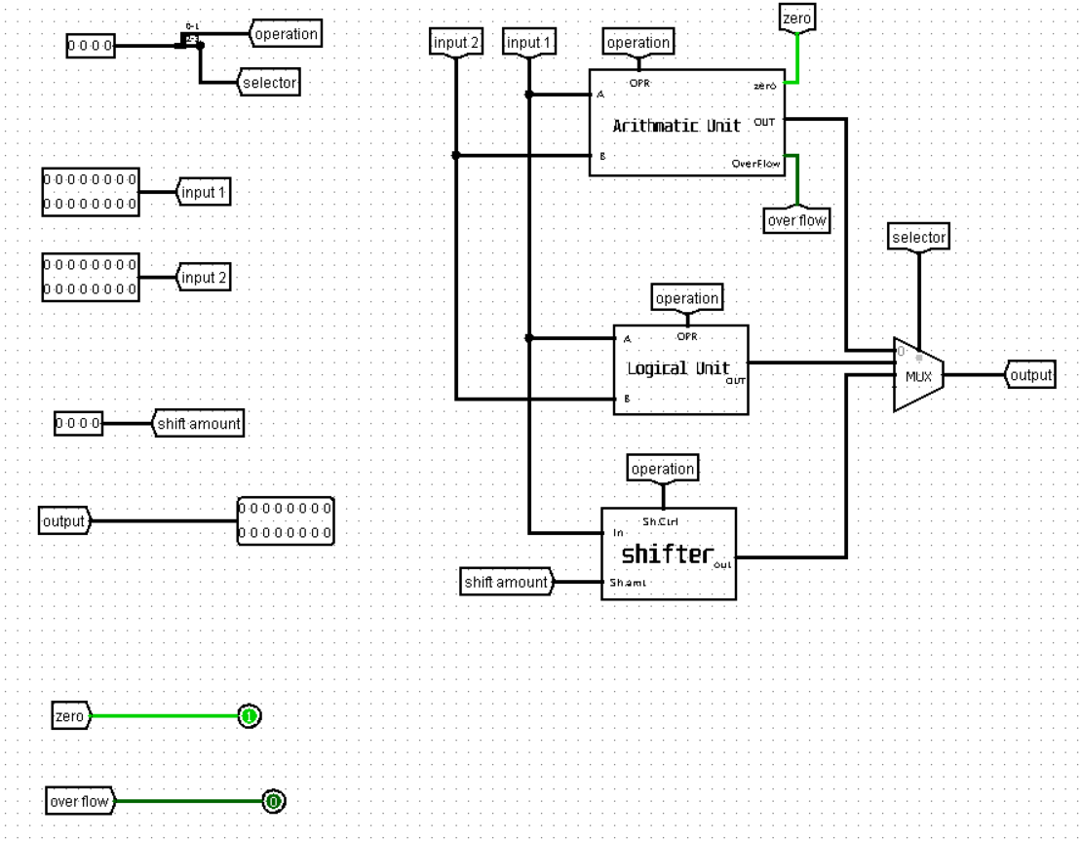

By working together, these three units within the ALU give the processor the power to perform a wide range of calculations and logical operations, making it the heart of the computer's processing power.

In the next sections, we'll explore each of these internal blocks of the ALU in more detail, diving deeper into their specific functionalities.

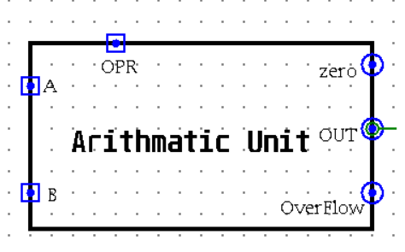**2.4.1. Arithmetic Unit**

The Arithmetic Unit (AU) is the core component within the ALU responsible for all arithmetic operations. It's essentially a high-speed calculator unit specifically designed for binary data manipulation within the processor.

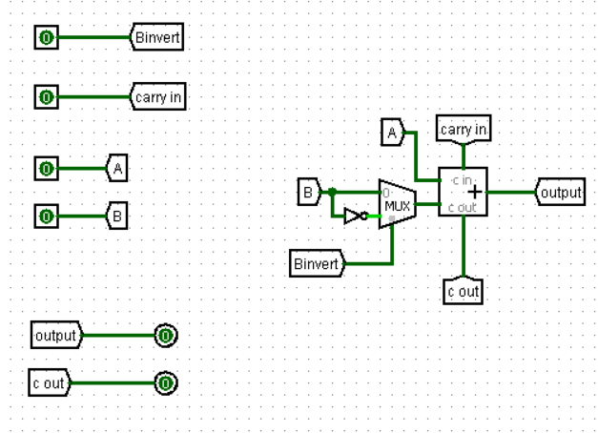The foundation of the AU lies in the humble 1-bit adder. This fundamental circuit can perform the addition of two single binary digits (bits), generating a sum output and a carry output. By cascading multiple 1-bit adders together, the AU can perform addition on larger binary numbers, like adding the contents of two registers within the processor.

The 1-bit adder itself doesn't inherently know whether to perform addition or subtraction. This decision is made by a control signal provided by the ALU control unit. This signal, often denoted as Cin (Carry In), dictates the adder's behavior:

* Cin = 0: When Cin is set to 0, the adder performs a standard addition of the two input bits (A and B).
* Cin = 1: When Cin is set to 1, the adder behaves differently. It takes the complement of the second input bit (B) and adds 1 (effectively performing 2's complement addition). This allows the AU to handle subtraction through clever manipulation.

In essence, the AU cleverly transforms subtraction into an addition problem using the power of 2's complement.

We'll need 16 of these 1-bit adders working together. Why 16? Because we want to handle 16-bit numbers, so each adder tackles one bit of the larger numbers.

Each adder has two inputs (A and B) and two outputs (sum and carry). We'll chain these adders together like dominos. The carry output from one adder becomes the carry input (Cin) for the next one, ensuring a smooth calculation across all 16 bits.

Our 16-bit input gets divided into 16 individual bits. Each bit is fed into one of our 16 adders.

Each adder produces a sum bit, which contributes to the final answer. We need to combine these 16 sum bits into the final result.

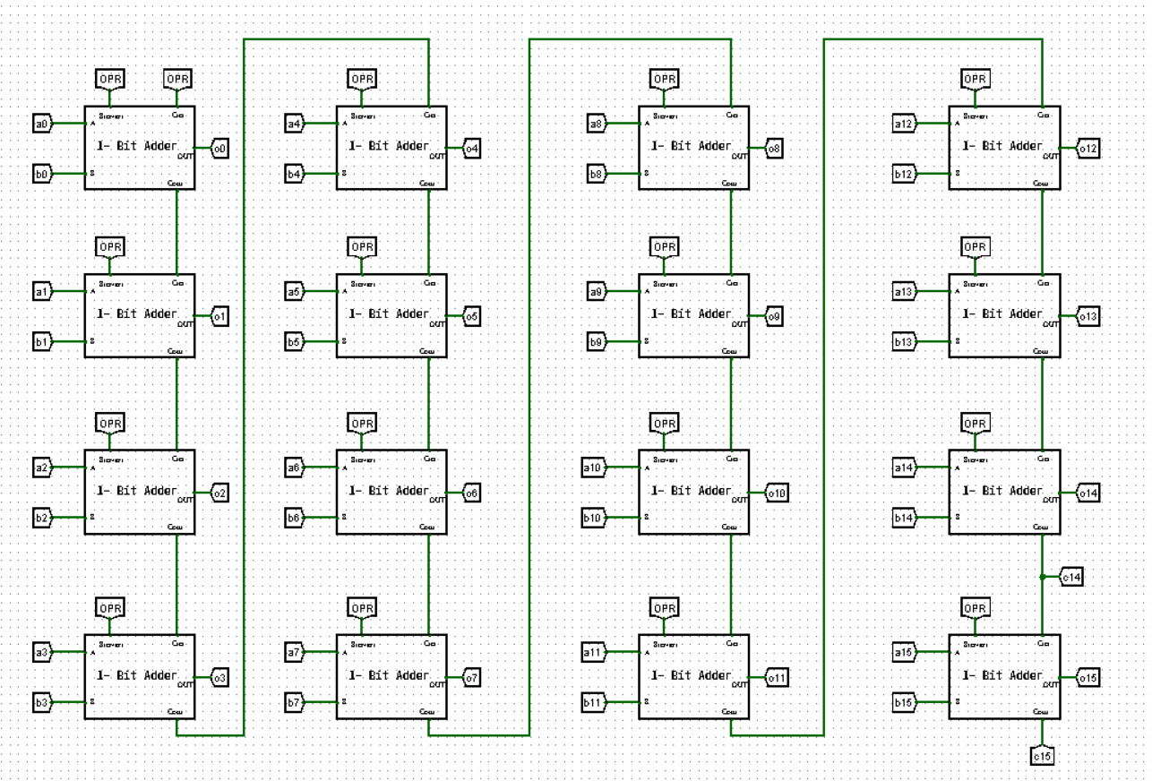

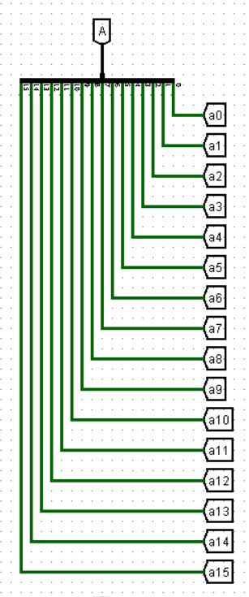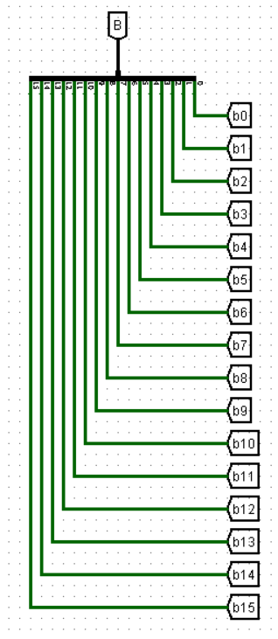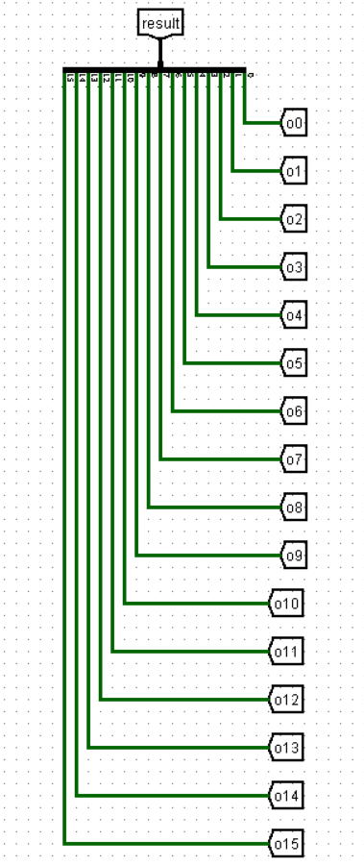

Now, we need a way to choose the final output based on what operation we want to perform (add, subtract, set less than (SLT), or set less than unsigned (SLTU)). Here's where a **multiplexer (MUX)** comes in.

We have a 2-bit control signal that acts like a switch setting. The MUX will connect the appropriate output to the final result line.

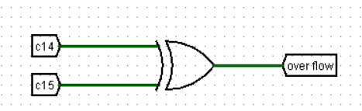***Overflow Flag:*** To detect overflow (when the result is too large to fit in the designated number of bits), we can use an XOR operation on the last two carry outputs (c14 and c15).

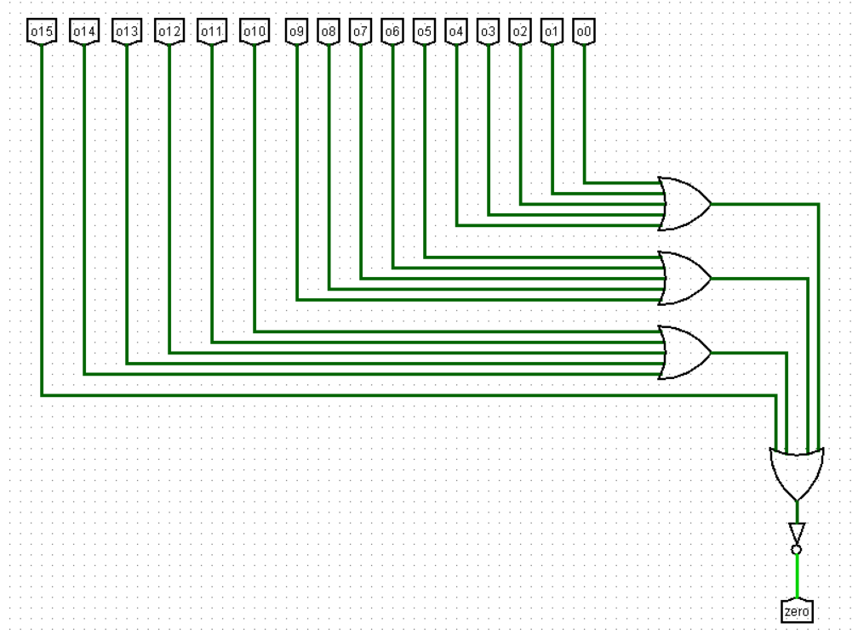

***The Zero Flag*** indicates whether the final result of the operation is zero or not. To determine this, we can perform an **OR operation** on all the 16 output bits from the adders. If the result of the OR operation is 0, it means all individual bits in the final result are 0, indicating a zero value. This zero flag can be a helpful signal for the processor to handle specific conditional statements or branching instructions in your code.

***SLT and SLTU:*** These operations determine if one number is less than another, considering signed or unsigned values. We can use the overflow flag and the last output bit (o15) to calculate SLT, while inverting the last carry (c15) gives us SLTU.

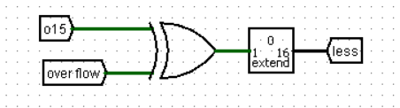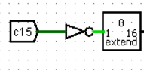

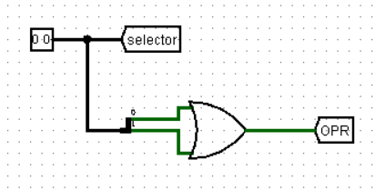***Operation Signal (opSignal):*** This is a crucial 1-bit signal that tells the first adder (remember, the one with the special Cin control) whether to perform a regular addition (opSignal = 0) or use 2's complement for subtraction. We'll achieve this by cleverly combining the 2-bit control signal using an AND operation.

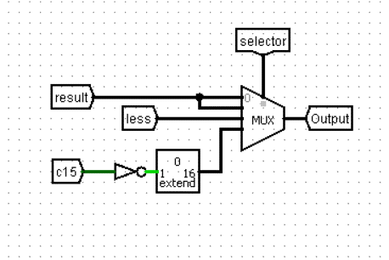

Connecting the MUX: Finally, the MUX connects the results from the 16 adders (for addition or subtraction) and the calculated SLT and SLTU outputs to the final result line based on the control signal.

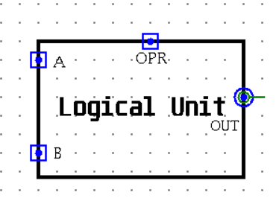**2.4.2. Logic Unit**

The Logic Unit (LU) keeps things simple. It only needs four basic logic gates (AND, OR, NOR, XOR) to work its magic. A 2-bit control signal acts like a code, telling a handy multiplexer (MUX) which gate to use.

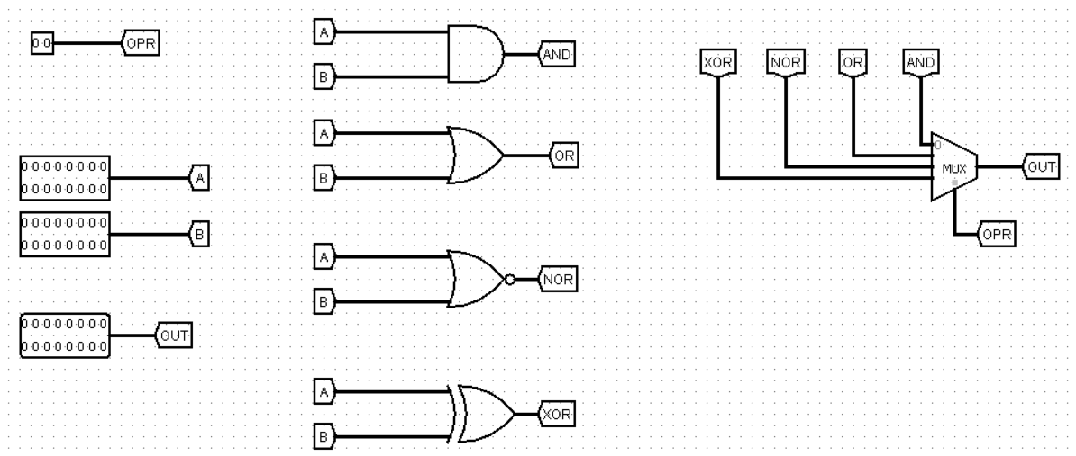***Internal Architecture***

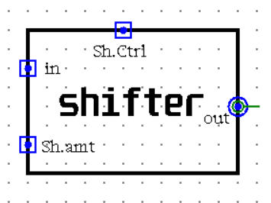**2.4.3. Shift Unit**

The Shift Unit focuses on one key task: **moving data bits around**.

Just like the LU, the Shift Unit avoids complexity, Four Basic "Shifting Moves": We just need these four built-in functions (SLL, SRL, SRA, ROR) to handle all the different nudge scenarios.

To control how many positions the bits are nudged, the Shift Unit also relies on a special **four-bit input** called the **shift amount**. This input acts like a precise instruction, telling the unit exactly how many marbles (data bits) to move in each operation (left or right shift).

Remember that awesome MUX from before? It makes a comeback here! A control signal tells the MUX which specific shifting move (SLL, SRL, SRA, or ROR) to perform on the data.

***Internal Architecture***

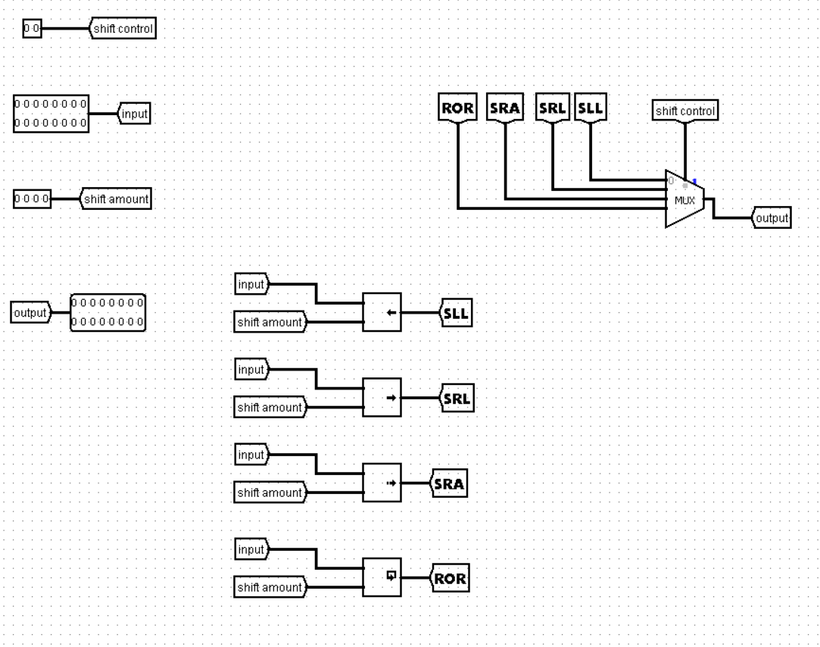

**Now, let's see how they work together!**

The Units Get Their Instructions: Each unit (AU, LU, and Shift) receives a special 2-bit control signal. This signal acts like a tiny code, telling the unit what specific task to perform.

The Shifter Gets Specific: In addition to the 2-bit control signal, the Shift Unit has a bonus input – a 4-bit shift amount. This input works like a precise instruction, specifying exactly how many positions to nudge the data bits (left or right) for various shifting operations.

Results Start Flowing: The AU outputs useful flags like zero and overflow to indicate specific conditions during calculations.

**The Multiplexer Steps Up:** A critical component in this stage is the multiplexer (MUX). The outputs from all three units (AU, LU, and Shift) are directed to the MUX for selection.

MUX Makes the Final Call: We only need a 2-bit control signal for the MUX (separate from the unit control signals). This 2-bit signal acts like a switch, telling the MUX which specific unit's output to send as the final ALU result.

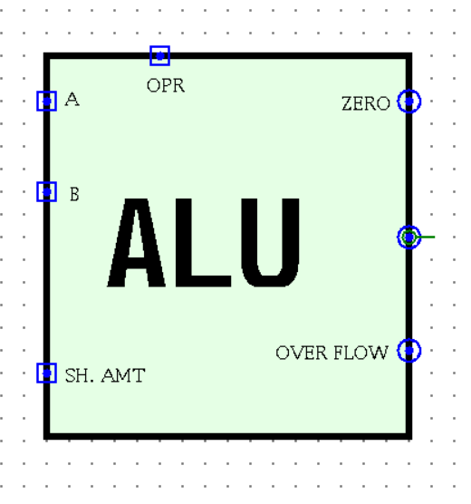

By combining these control signals, we end up with a 4-bit overall control signal for the ALU. Here's the breakdown:

* + 2 bits for the unit control signals (AU, LU, or Shift).
  + 2 bits for the MUX control signal (which unit's output to use).

With this efficient system, the ALU can perform various tasks based on the chosen operation and data manipulation needs.

**2.5. Extender**

The extender is a special circuit that takes this small immediate value (5 bits in our example) and expands it to a full size (maybe 16 bits, depending on the processor). This gives the tiny value the power to contribute to more complex operations!

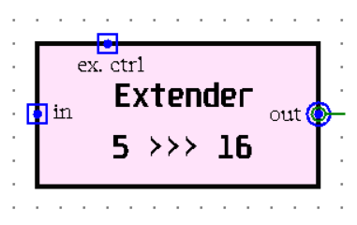

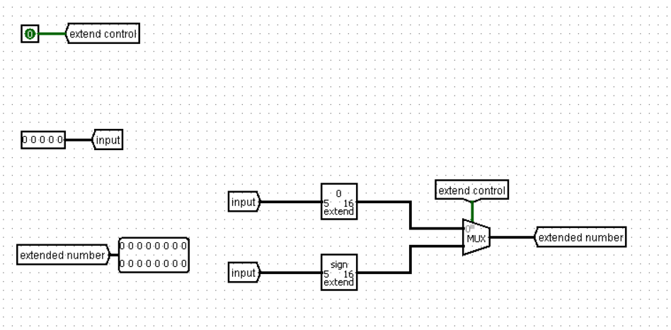***Internal Architecture***

**2.6. Data Memory**

The data memory operates akin to a Random Access Memory (RAM) system, offering both read and write functionalities. It encompasses five inputs: an address pathway for accessing data, a data pathway for inputting data to be stored, signals for MemWrite (activated when writing) and MemRead (activated when reading), and a clock signal for synchronization. Moreover, it possesses a sole output dedicated to delivering the retrieved data during read operations.

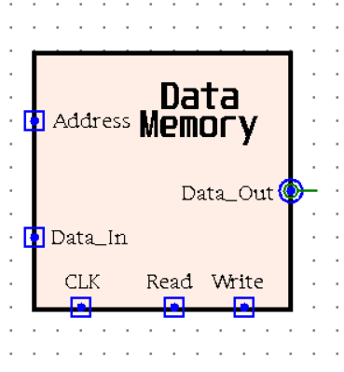

**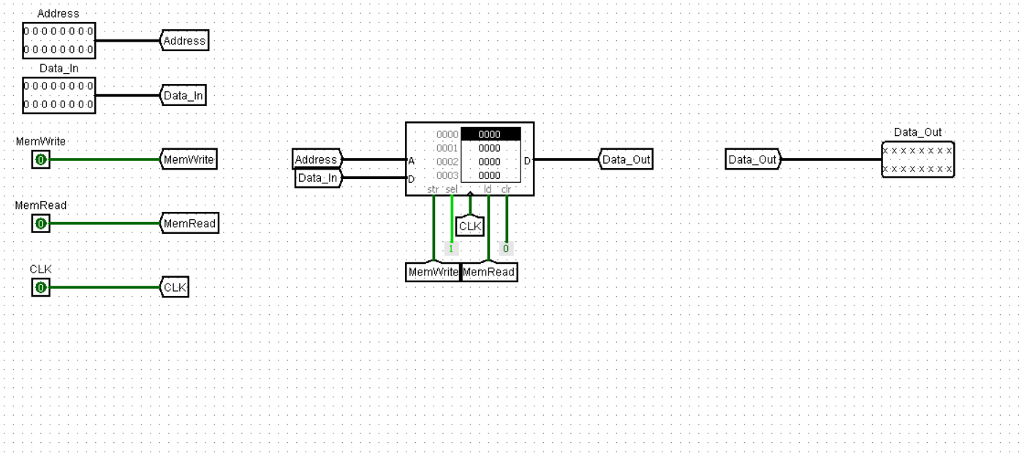*Internal Architecture***

**2.7. Control Unit**

Utilizing the 5-bit Opcode and 2-bit Function, the control unit orchestrates the execution of various operations based on the decoded instruction.

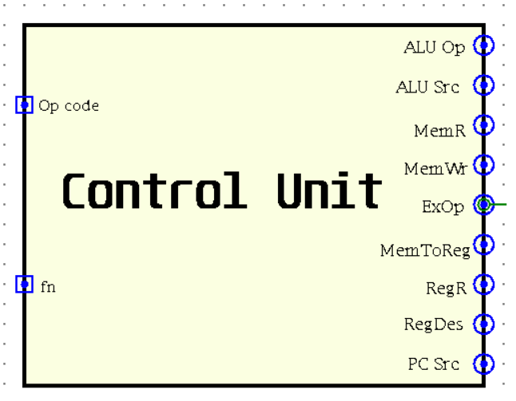

***The internal design***

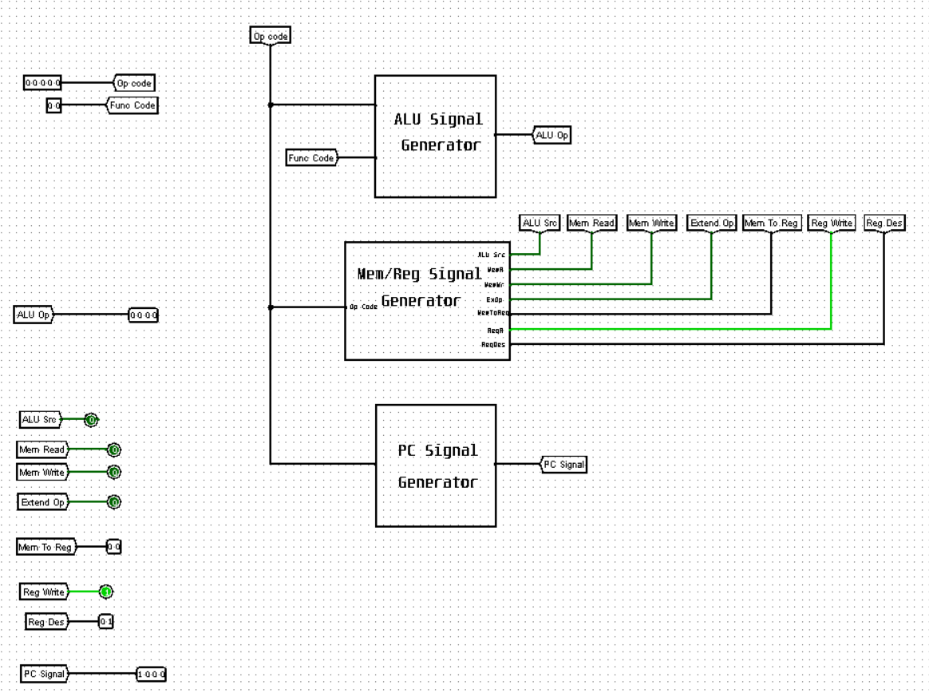

**7.1. Input signals**

***7.1.1. The Opcode (5-bit):***

The opcode tells the processor what to do (e.g., add, and, load, store, branch, jump…etc)

***7.1.2. The Function (2-bit):***

The R-type instruction format utilises the 2-bit function field to precisely control ALU operations.

***7.2. Output signals***

The output signals originate from three distinct subcircuits, each responsible for regulating various facets of the processor's functionality.

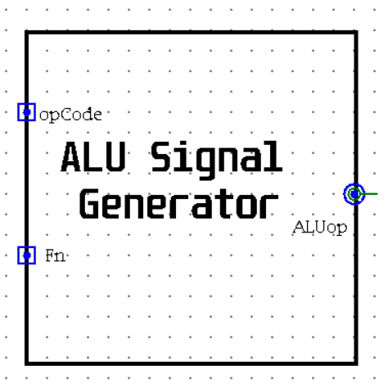 ***7.2.1 ALU signal generator:***

Utilising the Opcode and Function, It generates the **ALUop signal, a** **4-bit** **code** that dictates the ALU operation to be performed. The lower 2 bits determine the operation type (arithmetic, logic, or shift), while the upper 2 bits specify the particular operation (add, sub,etc., and, or, etc., sll, srl, etc.).

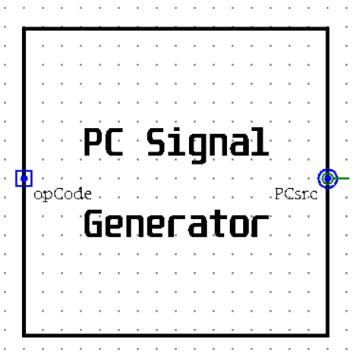

***7.2.2 PC signal generator:***

Itutilises the Opcode to generate a **4-bit PCsrc signal.** This signal determines the next Program Counter (PC) value, selecting between incrementing by 1, jumping to a specified address, or branching based on certain conditions.

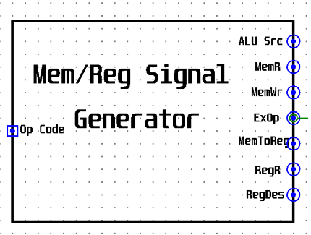***7.2.3 Mem/Reg signals generator:***

It employs the Opcode to derive values for the remaining control signals necessary for proper operation. These signals encompass various aspects of the CPU operation, such as memory access, register manipulation, and data transfer.

* + - 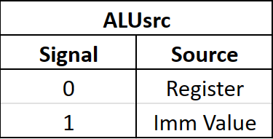**ALUsrc (1-bit):** This signal dictates the source of the second operand for the ALU. A logic value of 1 instructs the ALU to utilise the immediate value from the instruction, while a 0 specifies a register value (typically rt in the instruction).
    - 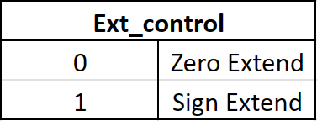**Ext_control (1-bit):** This signal controls the extension mode for immediate values. A logic value of 1 keeps the sign of the immediate, while a logic value of 0 sets the empty bits to zero.
    - **RegWrite (1-bit):** This control signal governs write operations to the register file. A logic value of 1 enables writing, allowing data to be stored in the designated register. Conversely, a logic value of 0 disables writing, preventing any changes to the register's content.
    - 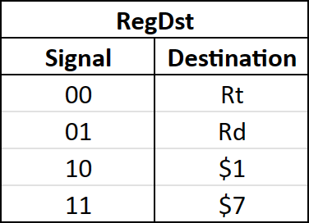**RegDst (2-bit):** This control signal selects the destination register for write operations based on the instruction type. It has different values depending on the instruction type: 0 for I-type instructions, 1 for R-type instructions, and 2 or 3 for jump instructions.
    - **MemRead (1-bit):** This signal tells the processor to grab data from memory. The control unit activates this signal whenever an instruction needs something from memory.
    - **MemWrite (1-bit):** This signal, on the other hand, tells the processor to write data to memory. The control unit activates it whenever an instruction needs to store something in memory.

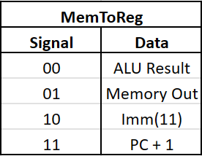

* + - **MemToReg (2-bit):** This control signal selects the data source for writing to the designated register.

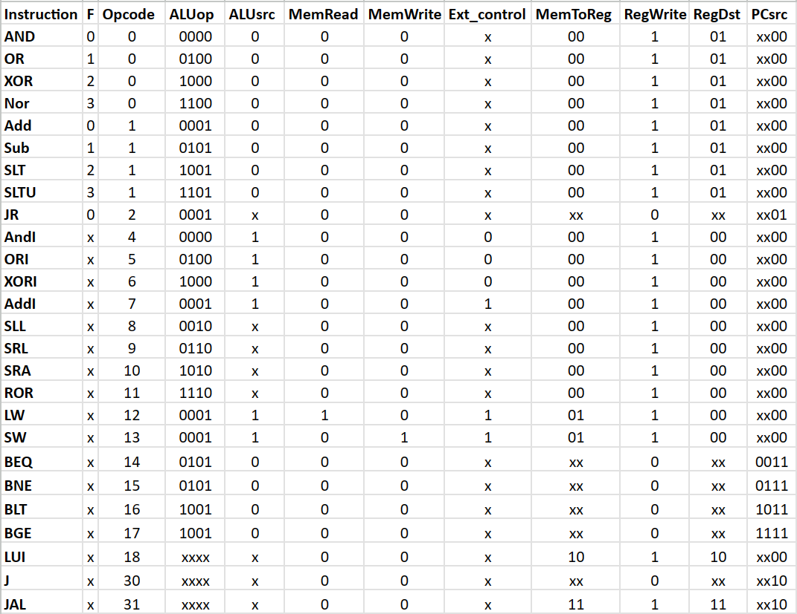**7.3. Signals values for each instruction**

|  |  |
| --- | --- |
| ***ALUop_0*** | ~OP3 ~OP2 OP0 + ~OP3 ~OP2 OP1 + ~OP3 OP1 OP0 + OP3 OP2 + OP4 |
| ***ALUop_1*** | OP3 ~OP2 |
| ***ALUop_2*** | ~OP4 ~OP3 ~OP2 ~OP1 F0 + ~OP3 OP2 ~OP1 OP0 + OP3 ~OP2 OP0 + OP3 OP2 OP1 |
| ***ALUop_3*** | ~OP3 ~OP2 ~OP1 F1 + ~OP2 OP1 OP0 + ~OP3 OP2 OP1 ~OP0 + OP3 ~OP2 OP1 + OP4 |

**7.4. Signals expressions**

|  |  |
| --- | --- |
| ***PCsrc_0*** | ~OP4 ~OP3 ~OP2 OP1 + ~OP4 OP3 OP2 OP1 + OP4 ~OP1 |
| ***PCsrc_1*** | OP3 OP2 OP1 + OP4 ~OP1 |
| ***PCsrc_2*** | OP0 |
| ***PCsrc_3*** | ~OP1 |

|  |  |
| --- | --- |
| ***RegDst_0*** | ~OP3 ~OP2 ~OP1 + OP4 OP3 |
| ***RegDst_1*** | OP4 |

|  |  |
| --- | --- |
| ***MemToReg_0*** | OP3 OP2 |
| ***MemToReg_1*** | OP4 |

|  |  |
| --- | --- |
| ***ALUsrc*** | ~OP3 OP2 + OP3 ~OP1 + OP4 OP1 |
| ***Ext_control*** | OP1 OP0 + OP3 |
| ***RegWrite*** | ~OP4 ~OP3 ~OP1 + ~OP4 ~OP1 ~OP0 + ~OP4 ~OP3 OP2 + ~OP4 OP3 ~OP2 + OP4 ~OP3 ~OP2 OP1 ~OP0 + OP4 OP3 OP2 OP1 OP0 |
| ***MemWrite*** | ~OP4 OP3 OP2 ~OP1 OP0 |
| ***MemRead*** | ~OP4 OP3 OP2 ~OP1 ~OP0 |

**3.Testing and verification**

In this phase, we implemented sum test programs to functionally validate the various sub-circuits constituting the overall circuit design.

**3.1. Test No.1 (Sum Array program)**

This program initializes an array and then calculates the sum of its elements. It achieves this through two functions:

* init_array: This function takes the array itself and its length as input (likely stored in registers) and fills the array with values from 1 to the length.
* sum_array: This function takes the array and its length as input and calculates the sum of all the elements in the array, returning the final sum.

The program utilizes registers to store temporary values during execution:

* $1: Stores the base address of the array in memory.
* $2: Stores the length of the array.
* $4: Likely used as a general-purpose argument register to pass data to the functions.
* $5: Stores the final sum returned by the sum_array function.

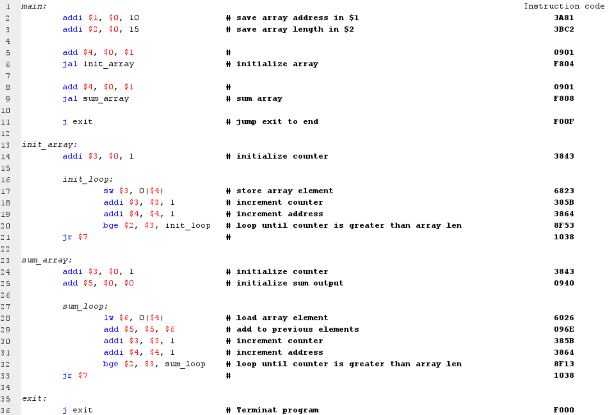 ***3.1.1. Assembly code and Instruction code***

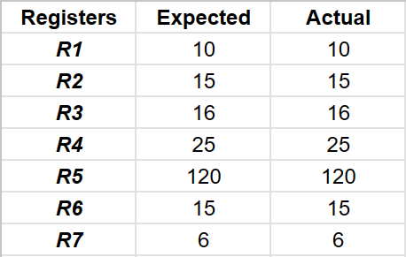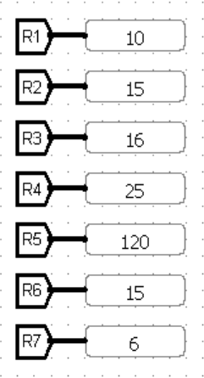 ***3.1.2. Registers Expected vs Actual values***

***Test Pass***

***3.1.3. Memory Expected vs Actual values***

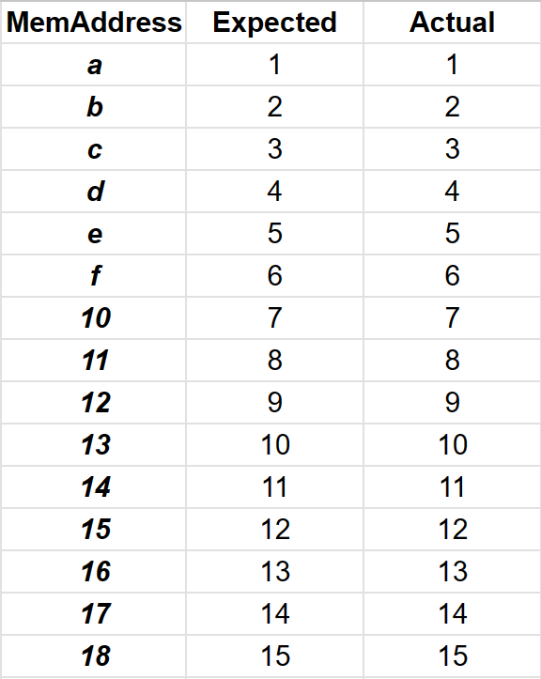

***Test Pass***

**3.2 Test No.2:**

The testing process of the test code sent by Eng. Jihad.

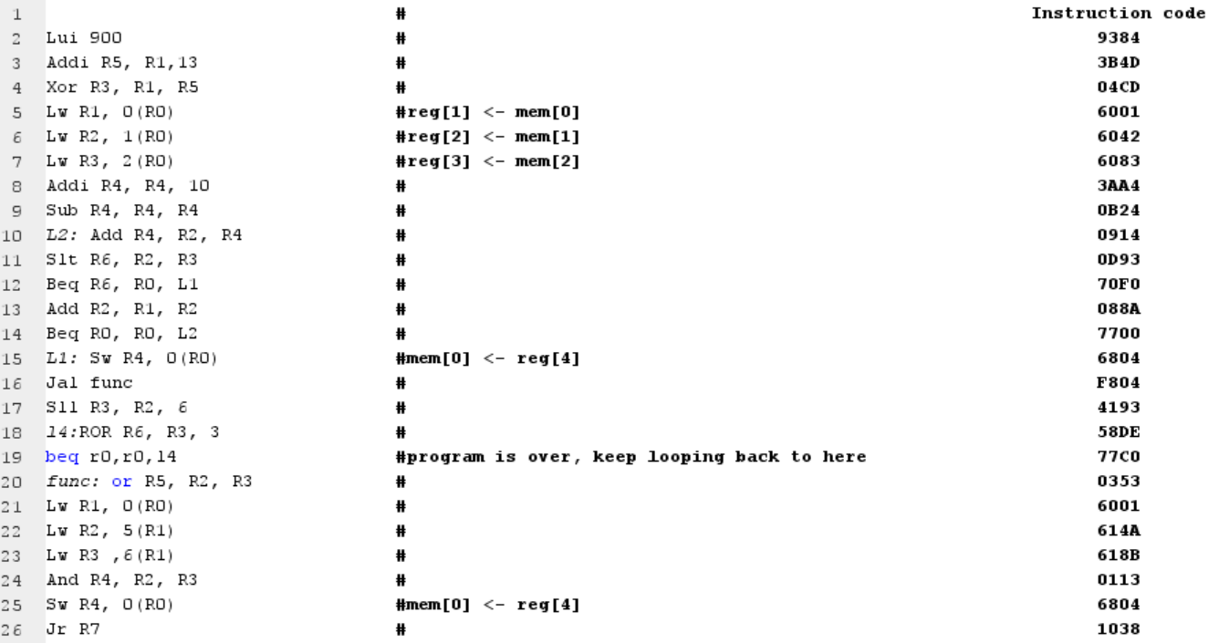 ***3.2.1.*** ***Assembly code and Instruction code***

***3.2.2. Registers Expected vs Actual values***

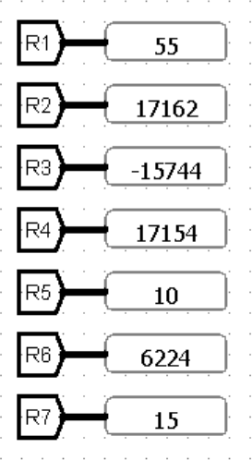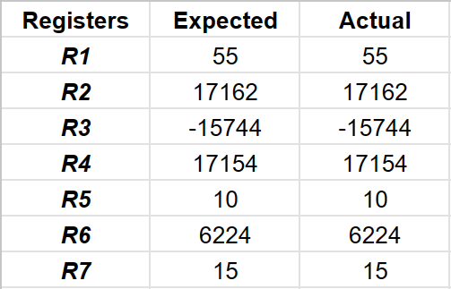

***Test Pass***

**3.3. Test No.3 (Loop, Store and Jump program)**

This code implements mechanisms to ensure the proper execution of store, jump, and branch instructions.

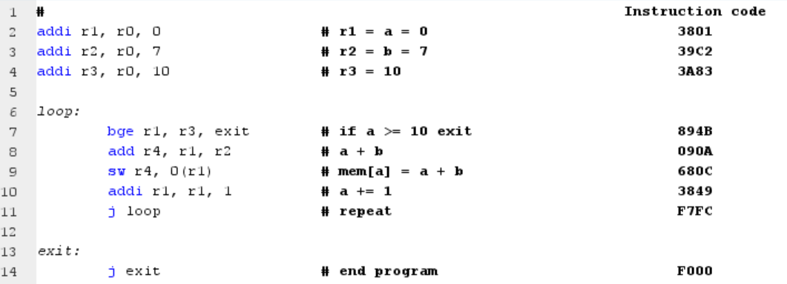 ***3.3.1. Assembly code and Instruction code***

***3.3.2. Registers Expected vs Actual values***

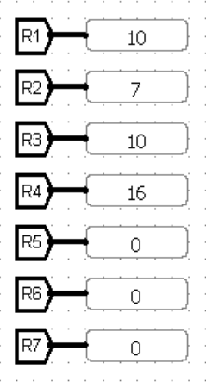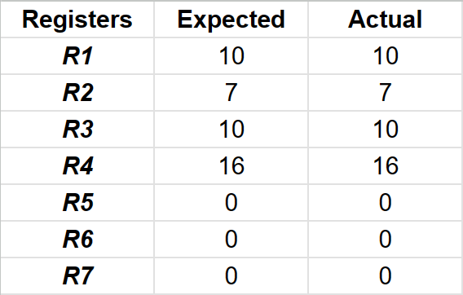

***Test Pass***

***3.3.3. Memory Expected vs Actual values***

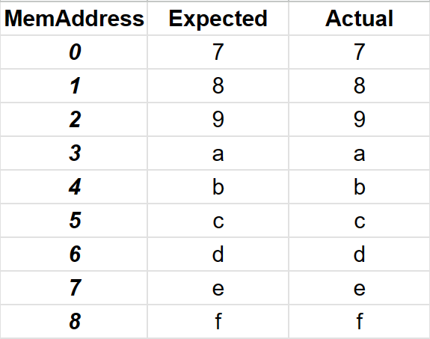

***Test Pass***

**3.4. Test No.4 (Load and Store program)**

This code ensures the proper execution of some essential instructions such as load upper immediately, jump, store, load and branch instructions.

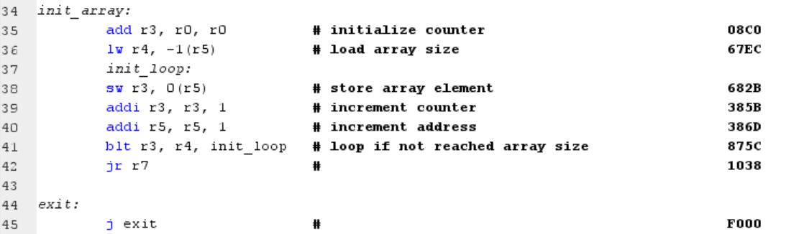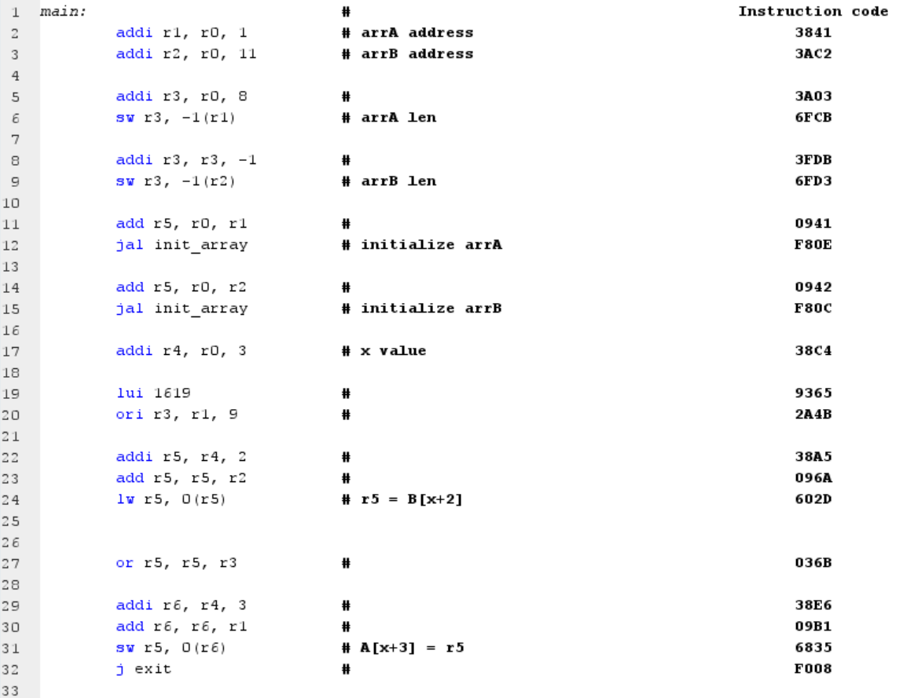 ***3.4.1. Assembly code and Instruction code***

***Test Pass***

***3.4.2. Registers Expected vs Actual values***

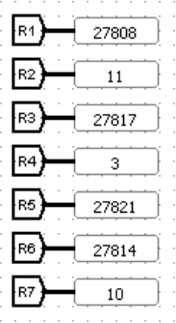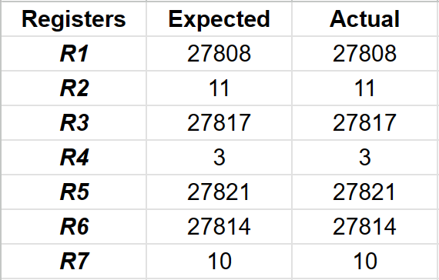

***3.3.3. Memory Expected vs Actual values***

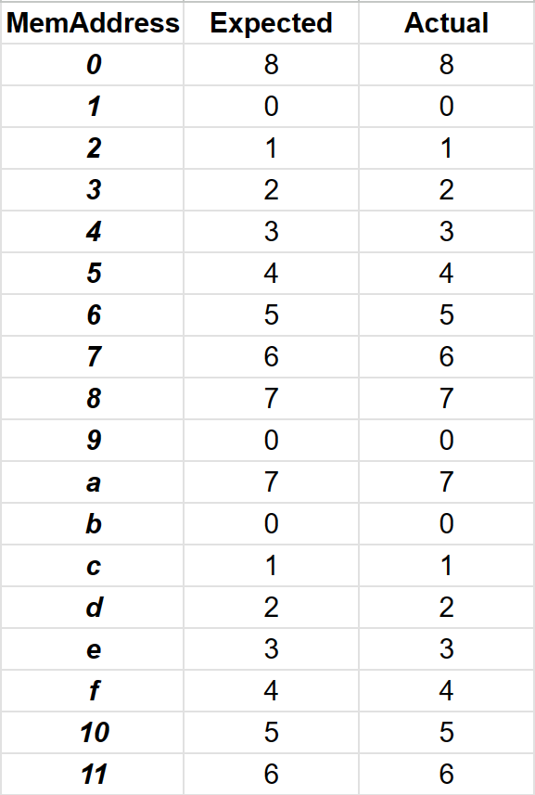

***Test Pass***

**3.5 Multiplication and Applications Test:**

**3.5.1 Multiplication Function:**

The objective of the implementation of the multiplication function is to be able to use it in in larger applications.

To achieve that we need to use a little of registers as possible. So we will need a virtual Stack.

The input of the function is in $5 and it will contain the address that contain the inputs in memory 0($5), 1($5) are the inputs. Uses $4, $3 to calculate the output, $2 as a counter but their values are preserved at the last 3 places in the memory each time you call the function. $6 will be used as the stack pointer only in this function so ITS VALUE IS NOT PRESERVED!

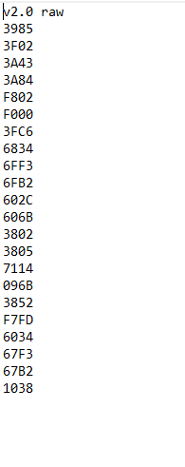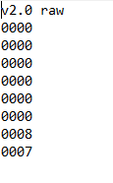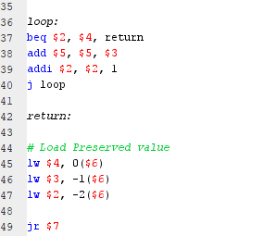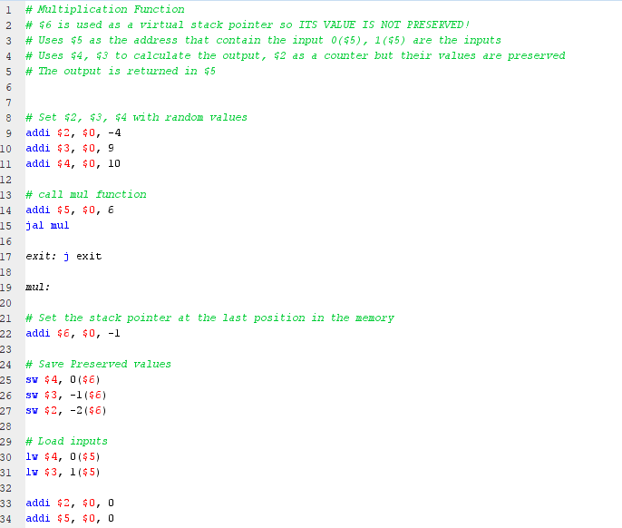***5.1.1 Assembly code and Instruction code Memory Inputs***

***5.1.2. Registers Expected vs Actual values***

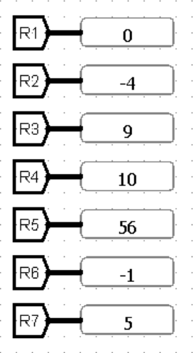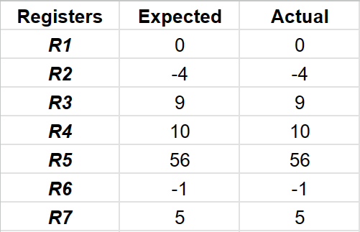

***Test Pass***

**3.5.2 Powers:**

In this test case we use the mul function (3.5.1) to calculate powers. The inputs are the first and second words in memory {0($0), 1($0)}. The output equals the first input raised to the power of the second input. The output is stored in R5

**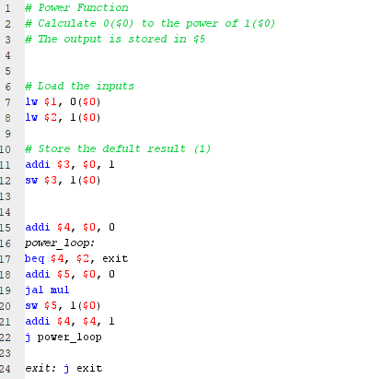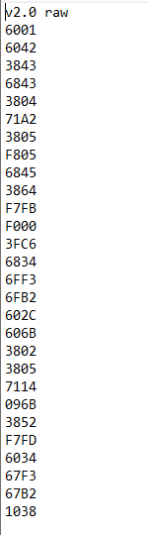*5.2.1 Assembly code and Instruction code Memory Inputs***

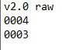

***5.2.2. Registers Expected vs Actual values***

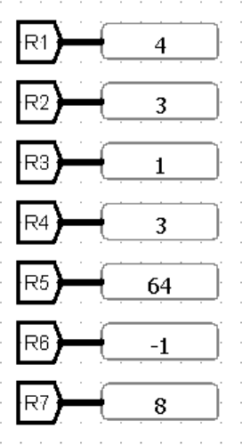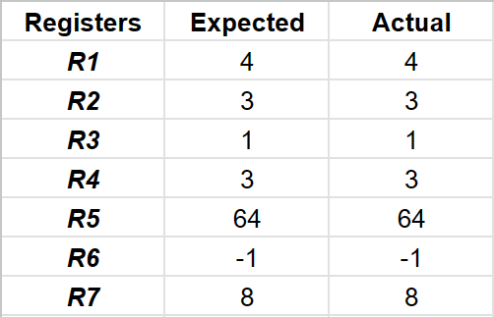

**3.5.3 Product of an array:**

In this test case we use the mul function (3.5.1) to calculate the product of an array stored in memory.

The inputs are R1 contains the address of the first element R2 contains the length of the array.

The output is stored in R5

***5.3.1 Assembly code and Instruction code Memory Inputs***

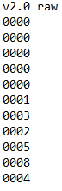

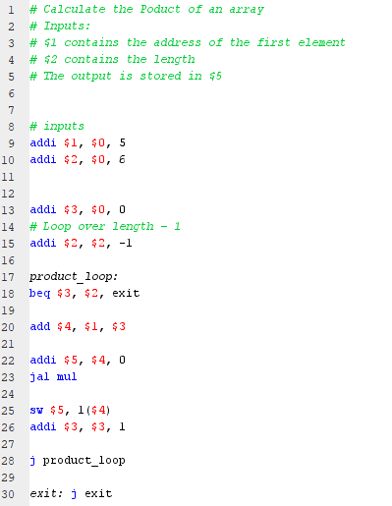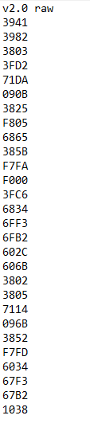

***5.3.2. Registers Expected vs Actual values***

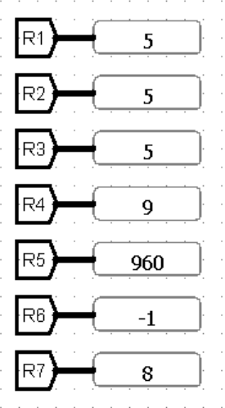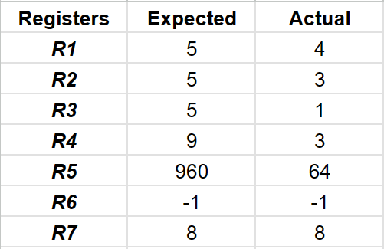

***Test Pass***

**3. Team work**

We implemented this processor using GitHub, we have done about 9 meetings since we started on the 1st of this month.

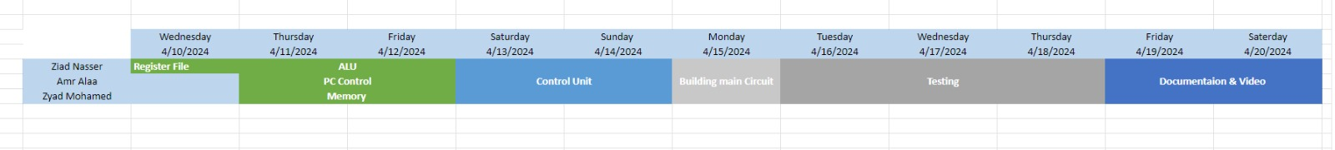**3.1. Work distribution chart**